Technical specification

VIDEO ad formats

Updated 01.09.2021

Spis treści

I. General rules 3
II. VIDEO formats 4
2.1. Pre-Roll/Mid-Roll/Post-Roll WWW APP TV 4
2.2. Branded pre-roll/mid-roll/post-roll WWW 5

General rules

The Form of the ad that enables the broadcast of video material as an advertising medium. The advertising film is equipped with standard navigation buttons that allow to stop it at any time, mute the sound, return to the beginning and repeat it.

  - The submitted creatives may not trigger warnings and errors while displayed, or otherwise disrupt the operation of the pages on which they are displayed. Ads which cause errors or warnings in the user’s browser will not be accepted for broadcast.
  - File names of the creatives provided should not include Polish characters or spaces, and the files should be marked as such: Advertiser/campaign_name_ad type_dimensions.extension (for example: interiapl_navibox_300x250.swf) or ad type_dimensions.extension (for example: banner_950x30.swf)
  - We require a complete set of creatives to be sent once, for the entire duration of the campaign, at least 3 working days before start. Otherwise, we do no guarantee the timely launch of the campaign;
  - The creatives have the size and weight specified in the detailed specification of a given ad format.
  - The complete set of creatives must be accompanied by an active address to which the creatives are to be directed after clicking - unless the creative is not to be clickable;
  - We reserve the right to change the resolution and reduce the number of frames per second as well as convert the received video to other formats.
  - The Ads/Sponsorship Billboards which are to be broadcast shall be delivered to POLSAT MEDIA digitally in the form of files delivered through the Polsat Media Adflow platform, compliant with the technical specification available at: https://adflow.polsatmedia.pl. Broadcast materials are stored for 3 months from the date of its last broadcast. After this term POLSAT MEDIA is entitle to erase this material without the necessity to inform the Advertiser about this fact.

VIDEO formats

Pre-Roll/Mid-Roll/Post-Roll WWW APP TV
Linear ad, in the form of the advertising spot broadcast before, during or after the video materials. Ad is available on all platforms, i.e on personal computers, mobile devices (mobile phones and tablets) and on the TV platform. The ad is clickable on all platforms except for the smart TV platform.
Required materials:
- Format – MP4
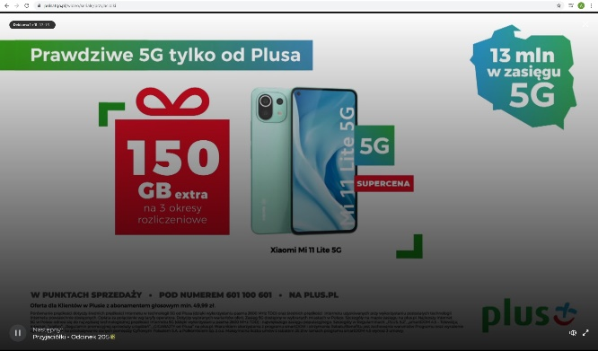
- Video encoding format - H264 / AVC
- Video encoding format profile - High
- Video bitrate - 9-15 Mb / s
- Resolution - 1920x1080
- Type of scan - progressive
- Pixel aspect ratio - 16: 9
- FPS - 25
- Audio encoding format - AAC
- Number of audio tracks - 2 (stereo)
- Sampling rate - 44.1 or 48.0 kHz
- File Size: No Restricions

Comments:
- spot must have an audio track in addition to the video track
- The above –mentioned resolutions refer to the effective area og video ad – i.e refer to the area without cartridges.
- Durations of the ad other than 30 seconds are allowed.

Branded pre-roll/mid-roll/post-roll WWW
A combination of a video ad with interactive elements placed directly above the played advertising spot.
Emission only during the advertising spot.

Required materials include two components:
- Video material prepared according to the guidelines for linear video advertising.
- Overlay – prepared according to the following guidelines:
- file size: up to 40kb
- format: JPG/PNG
- dimensions: any (recommended up to 650x150px in horizontal orientation and do 100x300px in vertical orientation)
Comments:
- Audio in the ad is allowed without user interaction.

